Group 7:

+ Trần Thái Thông – 20521984 (leader)

+ Trần Nhân Đức - 20521204

**Library Management System.**

This project aims to develop a system to help librarians manage the number of books and their readers. This system will manage card readers, book search, lending and returning books.

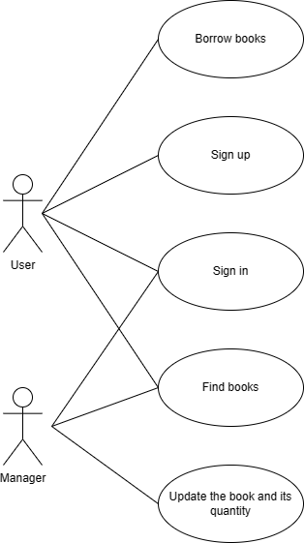We have two roles as manager and user. Managers can log in to the system to update, manage books and users. In addition, the manager can change the details, the number of books or add new books.

User must register an account to use the system. Users can search and borrow the books they want and be notified of the return date.

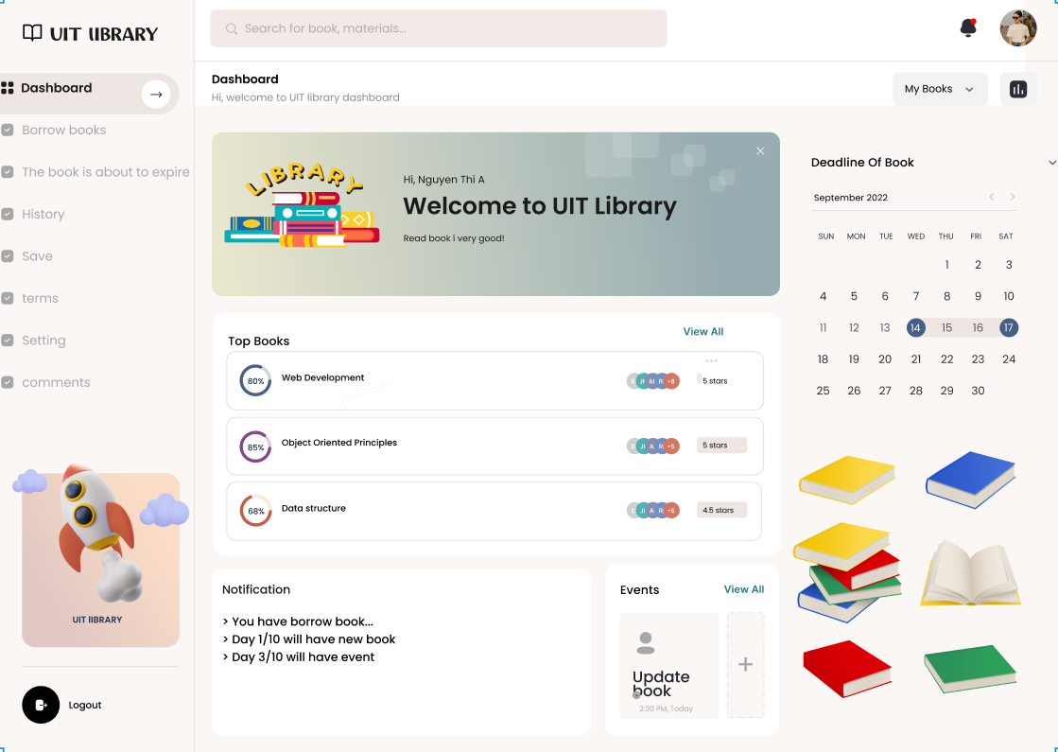

1. Registration function.

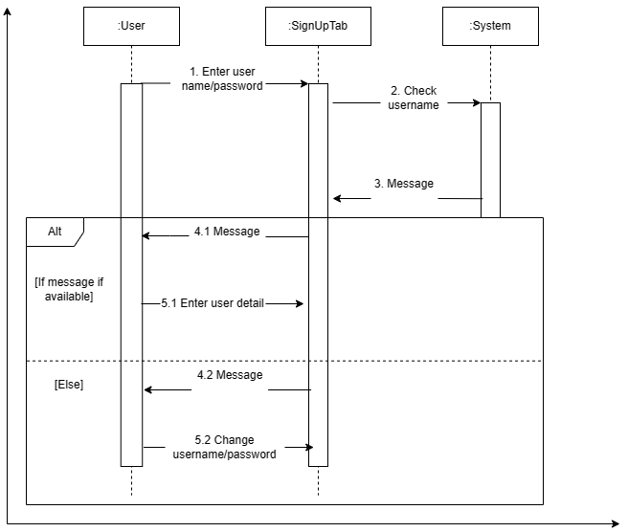

1. Login function.

1. Search function.

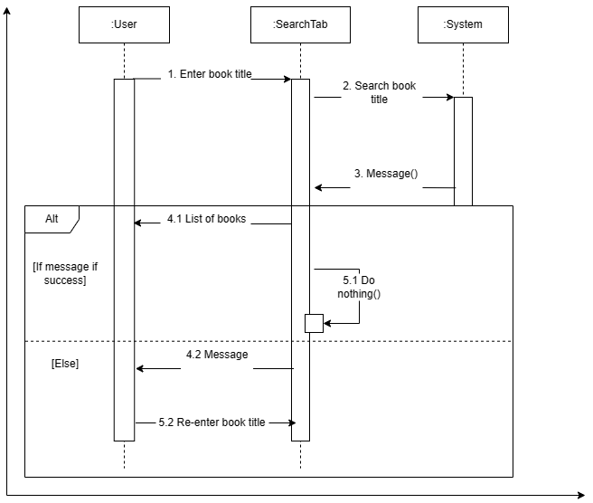

1. Borrow function.

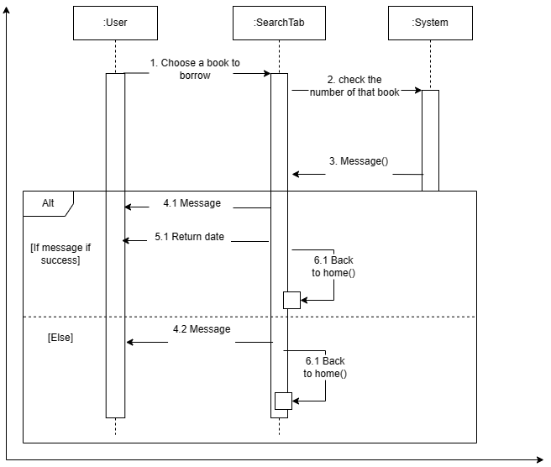

1. Update function.

